**WALMART SALES ANALYSIS QUERIES:**

**1.How many unique cities does the data have?**

SELECT DISTINCT(City) FROM Sales;

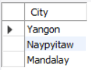

**2.In which city is each branch?**

SELECT CITY,BRANCH FROM sales

GROUP BY CITY,BRANCH;

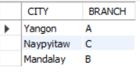

**3. How many unique product lines does the data have?**

SELECT DISTINCT(Product_line) FROM sales;

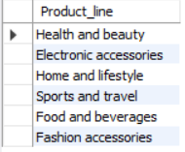

**4.What is the most common payment method?**

SELECT payment,SUM(Total) FROM sales

GROUP BY payment

ORDER BY SUM(Total) DESC ;

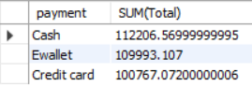

**5. What is the most selling product line?**

SELECT Product_line,SUM(Quantity) FROM Sales

GROUP BY Product_line

ORDER BY SUM(Quantity) DESC;

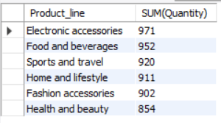

**6. What is the total revenue by month?**

SELECT Month,SUM(Total) FROM Sales

GROUP BY Month

ORDER BY SUM(Total) DESC ;

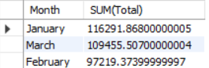

**7. What month had the largest COGS?**

SELECT Month,SUM(cogs) FROM Sales

GROUP BY Month

ORDER BY SUM(cogs);

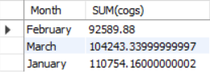

**8. What product line had the largest revenue?**

SELECT Month,SUM(gross_income) FROM Sales

GROUP BY Month

ORDER BY SUM(gross_income) DESC;

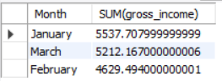

**9. What is the city with the largest revenue?**

SELECT City,SUM(gross_income) FROM Sales

GROUP BY City

ORDER BY SUM(gross_income) DESC;

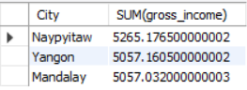

**10. What product line had the largest VAT?**

SELECT Product_line,SUM(VAT) FROM Sales

GROUP BY Product_line

ORDER BY SUM(VAT) DESC**;**

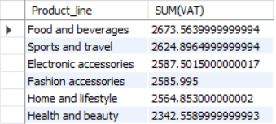

**11.** **Fetch each product line and add a column to those product line showing "Good", "Bad". Good if its greater than average sales**

SELECT Product_line,

CASE

WHEN SUM(Quantity)>=AVG(Quantity) THEN "GOOD"

ELSE "BAD"

END

AS Review

FROM Sales

GROUP BY Product_line;

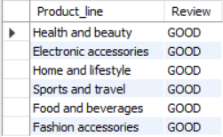

**12. Which branch sold more products than average product sold?**

SELECT Branch FROM Sales

GROUP BY Branch

HAVING SUM(Quantity)>=AVG(Quantity);

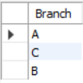

**13.** **What is the most common product line by gender?**

SELECT Gender,Product_line,COUNT(Gender) FROM Sales

GROUP BY Gender,Product_line

ORDER BY COUNT(Gender) DESC;

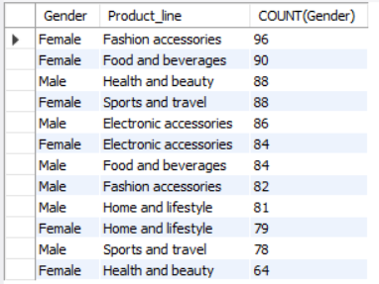

**14. What is the average rating of each product line?**

SELECT Product_line,AVG(Rating) FROM Sales

GROUP BY Product_line

ORDER BY AVG(Rating) DESC;

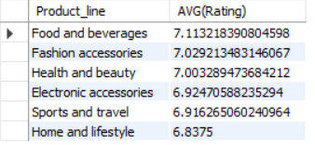

**15**. **Number of sales made in each time of the day per weekday**

SELECT Time_of_day,COUNT(Quantity) FROM Sales

WHERE Day="Monday"

GROUP BY Time_of_day

ORDER BY COUNT(Quantity) DESC;

IN DAY NAME SPECIFY DAY OF WEEK

**16. Which of the customer types brings the most revenue?**

SELECT Customer_type,SUM(Total) FROM Sales

GROUP BY Customer_type

ORDER BY SUM(Total) DESC;

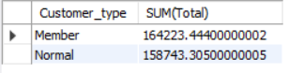

**17. Which city has the largest tax percent/ VAT?**

SELECT City,SUM(VAT) FROM Sales

GROUP BY City

ORDER BY SUM(VAT) DESC;

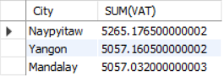

**18. Which customer type pays the most in VAT?**

SELECT Customer_type,SUM(VAT) FROM Sales

GROUP BY Customer_type

ORDER BY SUM(VAT) DESC;

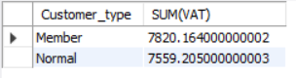

**19. How many unique customer types does the data have?**

SELECT DISTINCT(Customer_type) FROM sales;

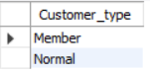

**20. How many unique payment methods does the data have?**

SELECT DISTINCT(Payment) FROM SALES;

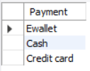

**21. What is the most common customer type?**

SELECT Customer_type,COUNT(*) FROM Sales

GROUP BY Customer_type

ORDER BY COUNT(*) DESC;

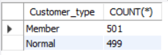

**22. Which customer type buys the most?**

SELECT Customer_type,SUM(Quantity) FROM Sales

GROUP BY Customer_type

ORDER BY SUM(Quantity) DESC**;**

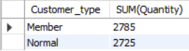

**23. What is the gender of most of the customers?**

SELECT Gender,COUNT(*) FROM Sales

GROUP BY Gender

ORDER BY COUNT(*) DESC;

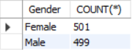

**24. What is the gender distribution per branch?**

SELECT Branch,Gender,COUNT(*) FROM SALES

GROUP BY Branch,Gender

ORDER BY COUNT(*);

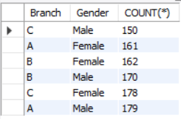

**25. Which time of the day do customers give most ratings?**

SELECT Time_of_day,AVG(Rating) FROM SALES

GROUP BY Time_of_day

ORDER BY AVG(Rating) DESC;

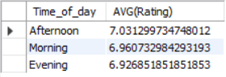

**26. Which time of the day do customers give most ratings per branch?**

SELECT Time_of_day,Branch,AVG(Rating) FROM SALES

GROUP BY Time_of_day,Branch

WHERE Branch =”A”

ORDER BY AVG(Rating) DESC;

**27. Which day fo the week has the best avg ratings?**

SELECT Day,AVG(Rating) FROM SALES

GROUP BY day

ORDER BY AVG(Rating) DESC;

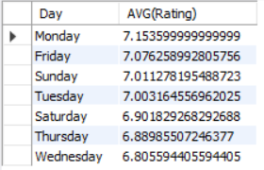

**28. Which day of the week has the best average ratings per branch?**

SELECT Day,AVG(Rating) FROM SALES

WHERE BRANCH ="A"

GROUP BY day

ORDER BY AVG(Rating) DESC;

CALCULATED COLUMNS

## Revenue And Profit Calculations

$ COGS = unitsPrice * quantity $

$ VAT = 5\% * COGS $

$VAT$ is added to the $COGS$ and this is what is billed to the customer.

$ total(gross_sales) = VAT + COGS $

$ grossProfit(grossIncome) = total(gross_sales) - COGS $

**Gross Margin** is gross profit expressed in percentage of the total(gross profit/revenue)

$ \text{Gross Margin} = \frac{\text{gross income}}{\text{total revenue}} $